Overview of YAML

- The definition of a YAML file
- Why developers use YAML
- The relationship between YAML and JSON and XML
- The basic structure of a YAML file
- How to use a YAML file in Kubernetes

Definition of a YAML file
Before going further, you need to understand the definition of YAML. According to www.yaml.org, “YAML is a human-friendly, data serialization standard for all programming languages.”
YAML was created specifically for common use cases such as:
- Configuration files
- Log files
- Inter-process messaging
- Cross-language data sharing
- Object persistence
- Complex data structures

Why you should use YAML
There are a few advantages to using YAML files:
- Easily readable by humans, YAML files are are expressive and extensible.
- They are easy to implement and use.
- They are easily portable between programming languages.
- They match the native data structures of agile languages.
- YAML files have a consistent model to support generic tools.
- They support one-pass processing.
- Convenient to use, so you no longer need to add all of our parameters to the command line.
- Maintenance can be done – YAML files can be added to the source control to track the changes.
- Flexibility – You can create much complex structures using YAML than you can use on command line

Relationship to JSON and XML
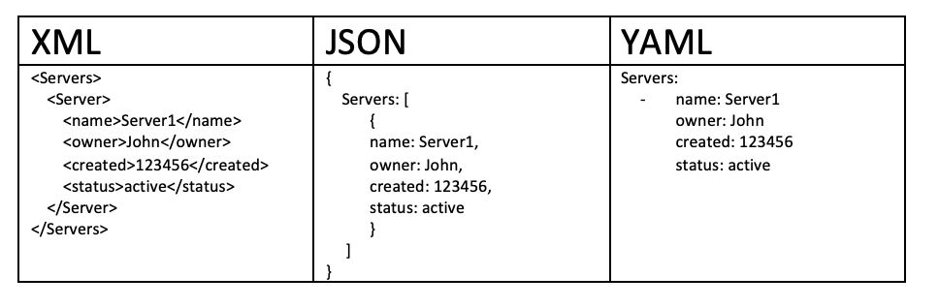
XML is a pioneer in many domains. XML was originally designed to be backwards compatible with the Standard Generalized Markup Language (SGML), which was designed to support structured documentation. Because of this, there are many design constraints with XML.
JSON’s design goal is simplicity and universality, with its goal to generate and parse. It has reduced human readability, but its data can be processed easily by every modern programming environment.
YAML’s design goals are human readability and a more complete information model. YAML is more complex to generate and parse, therefore it can be viewed as a natural superset of JSON. Every JSON file is also a valid YAML file.
All this to say, it makes it easy to migrate from JSON to YAML if/when the additional features are required. YAML is the result of lessons learned from XML.

The structure of a YAML file
The following are the building blocks of a YAML file:
- Key Value Pair – The basic type of entry in a YAML file is of a key value pair. After the Key and colon there is a space and then the value.
- Arrays/Lists – Lists would have a number of items listed under the name of the list. The elements of the list would start with a -. There can be a n of lists, however the indentation of various elements of the array matters a lot.
- Dictionary/Map – A more complex type of YAML file would be a Dictionary and Map.
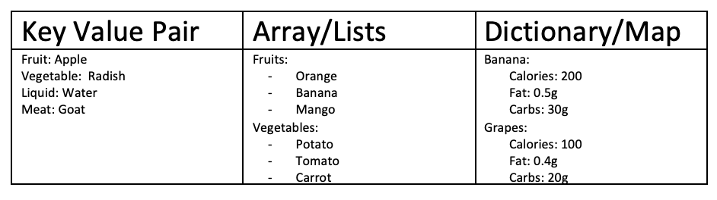

General guidelines when writing YAML files
Keep in mind the following guidelines when you write a YAML file:

The importance of indentation and tabs
Consider the below diagram, which has details about “Banana.” There are 3 attributes:
- Calories = 200
- Fat = 0.5g
- Carbs = 30g
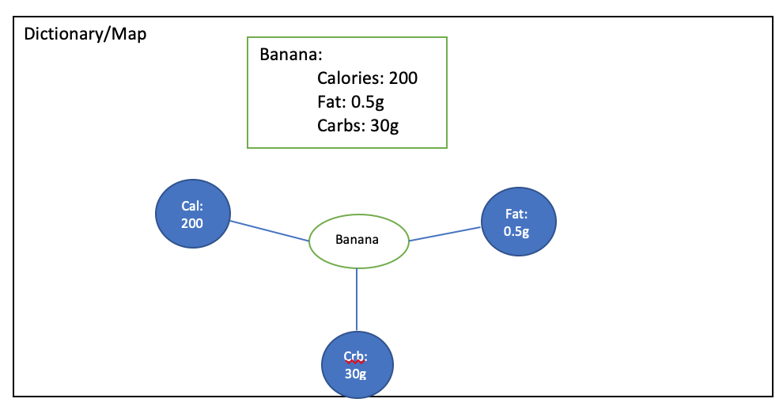
Suppose there is an extra indentation or tabs used – then the whole meaning of the YAML object changes as you can see below. Hence the need for us to be careful with respect to indentation and tabs when it comes to your YAML files.
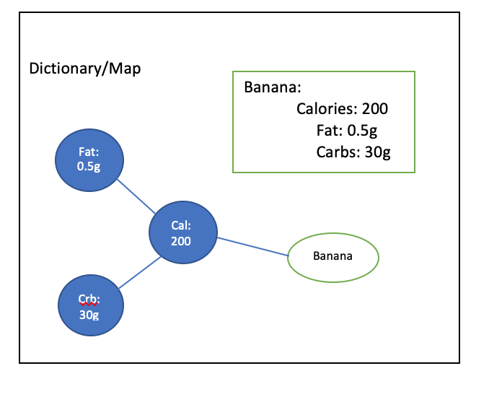

Important aspects of YAML basics
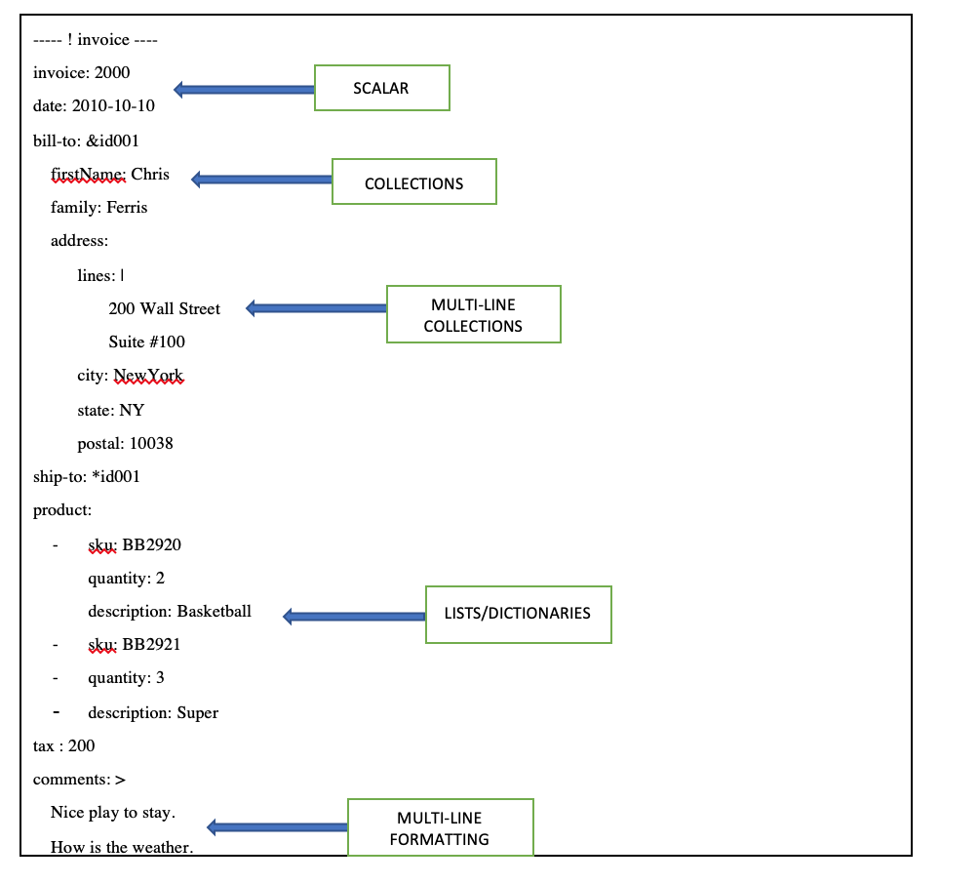
Other aspects that you need to concentrate on when you create YAML files include:
- SCALAR – You can mention date in the format “YYYY-MM-DD” and assign it to a date variable.
- COLLECTIONS – Suppose you mentioned the billing address, and the shipping address is the same as the billing address. Then you make use of & followed by an ID in front of billing address. If you need to copy the same address against the shipping address, then * symbol is used along with the same id used in billing address. This helps redundancy of the data.
- MULTI-LINE COLLECTIONS – Suppose you have an address line, which has multiple lines and need to maintain the format then use | (vertical bar) symbol.
- LISTS/DICTIONARIES – Lists and dictionaries are covered in the previous section.
- MULTI-LINE FORMATTING – Suppose you have a long character string value and need to mention on multi-lines maintaining the formatting, then you make use of the symbol > as mentioned above.

Step-01: Comments & Key Value Pairs
Space after colon is mandatory to differentiate key and value
# Defining simple key value pairs
name: user1
age: 23
city: Bengaluru

Step-02: Dictionary / Map
Set of properties grouped together after an item
Equal amount of blank space required for all the items under a dictionary
person:
name: user1
age: 23
city: Bengaluru

Step-03: Array / Lists
Dash indicates an element of an array
person: # Dictionary
name: user1
age: 23
city: Bengaluru
hobbies: # List
- cycling
- cookines
hobbies: [cycling, cooking] # List with a differnt notation

Step-04: Multiple Lists
Dash indicates an element of an array
person: # Dictionary
name: user
age: 23
city: Bengaluru
hobbies: # List
- cycling
- cooking
hobbies: [cycling, cooking] # List with a differnt notation
friends: #
- name: friend1
age: 22
- name: friend2
age: 25

